
SRM Institute of Science and Technology
Mode of Exam
OFFLINE
College of Engineering and Technology
School of Computing
SRM Nagar, Kattankulathur – 603203, Chengalpattu District, Tamilnadu
Academic Year: 2024 (EVEN) SET-C
Test: CLAT-1 Date:
Course Code & Title: 18CSC304J -COMPILER DESIGN Duration: 50 Min
Year & Sem: III & VI Max. Marks: 25

Course Articulation Matrix:
S.No. | Course Outcome | PO1 | PO2 | PO3 | PO4 | PO5 | PO6 | PO7 | PO8 | PO9 | PO10 | PO11 | PO12
1 | CO1 | 3 | 3 | 3

Part – A ( 5 x 1 = 5 Marks)
Instructions: Answer ALL
Q. No | Question | Marks | BL | CO | PO | PI Code
1 | The regular expression (0|1)*(0|1) represents a language with  - Nonempty binary strings  - Empty and nonempty binary strings  - Odd nonempty strings  - Even nonempty strings  Ans a | 1 | 2 | 1 | 1 | 1.4.1
2 | The total number of states to build the given language using DFA: L={w|w has exactly 2 a’s and at least 2 b’s}  - 10 b) 11 c)12 d)13  Ans a | 1 | 3 | 1 | 2 | 2.1.3
3 | Which of the following is not a regular expression?  a) [(a+b)*-(aa+bb)]*  b) [(0+1)-(0b+a1)*(a+b)]*  c) (01+11+10)*  d) (1+2+0)*(1+2)*  Ans b | 1 | 2 | 1 | 2 | 2.1.2
4 | Regular expression Φ* is equivalent to  a) ϵ b) Φ c) 0 d) 1  Ans a | 1 | 1 | 1 | 1 | 1.2.1
5 | ________________takes collection of rules that define the translation of each operation of the intermediate language into the machine language for the target machine.  - Parser generators  - Scanner generators  - Syntax-directed translation engines  - Automatic code generators  Ans d | 1 | 1 | 1 | 1 | 1.3.1
Part – B ( 2 x 4 = 8 Marks)
Instructions: Answer any TWO
6 | The two tests schemes can be reduced to one in input buffering technique? justify your answer with an algorithm.  Answer  The two tests can be reduced to one, if each buffer half holds a sentinel character at the end.  The sentinel is a special character of eof.  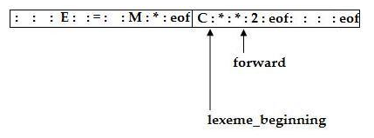  forward := forward + 1’  if forward = eof then begin  if forward at end of first half then begin  reload second half;  forward := forward + 1  end  else if forward at end of second half then begin  reload first half;  move forward to beginning of first half  end  else  terminate lexical analysis  end | 4 | 1 | 1 | 1 | 1.3.1
7 | Raju is authoring a book on compiler. He makes sure that the first page is an index page followed by two acknowledgement pages. Design a DFA for the language L=all strings over {a,b}.  Note: index page and acknowledgment pages are referred to strings ‘a’, ‘b’ respectively.  Answer  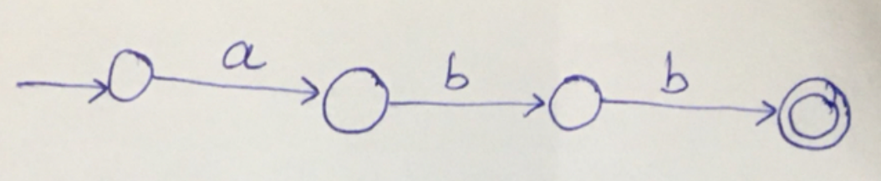 | 4 | 2 | 1 | 2 | 2.3.1

8 | Construct the minimal DFA for the below diagram.  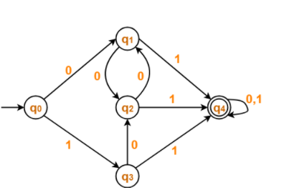  Answer  First Construct Transition table for the given diagram  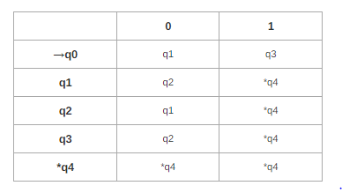  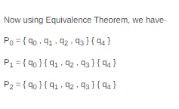  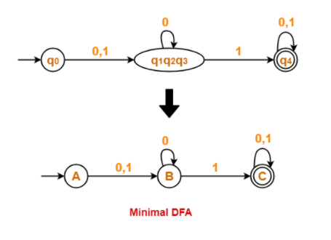 | 4 | 3 | 1 | 2 | 2.3.1
Part – C ( 1 x 12 = 12 Marks)
Instructions: Answer any ONE
9 | (a) Consider the input c=a+b*5. With a neat sketch, illustrate how the input is transformed into assembly code, using all the phases of compiler.  (Problem solving-4 marks, explanation-4)  Answer  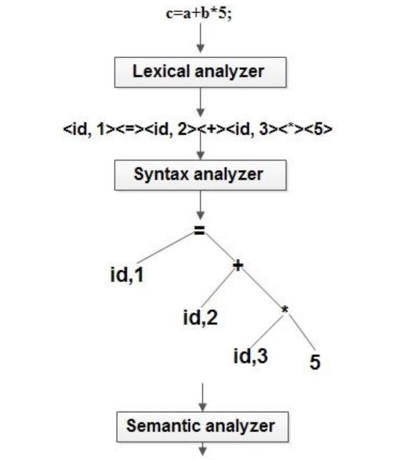  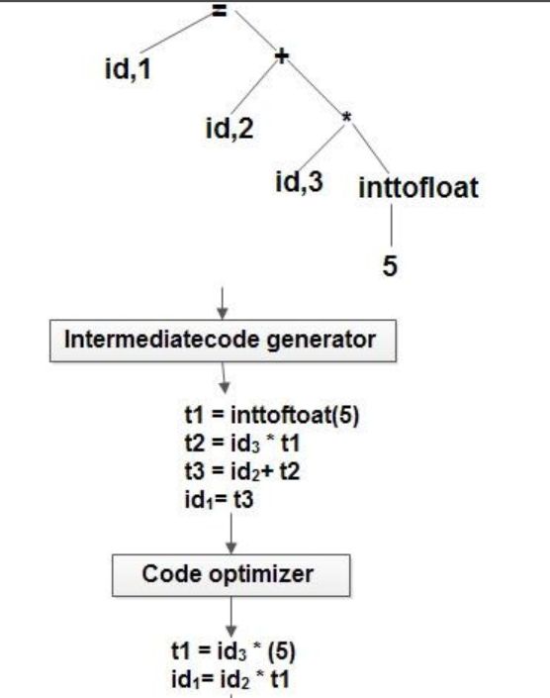  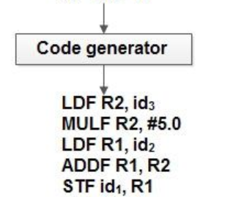  Answer  (ii). Illustrate LEX code with an example.  %{  #include <stdio.h>  #include "y.tab.h"  int c;  extern int yylval;  %}  %%  " " ;  [a-z] {  c = yytext[0];  yylval = c - 'a';  return(LETTER);  }  [0-9] {  c = yytext[0];  yylval = c - '0';  return(DIGIT);  }  [^a-z0-9\b] {  c = yytext[0];  return(c);  } | 9  3 | 2 | 1 | 2 | 2.2.1
OR
 | - A famous textile showroom is giving a super sale offer in which the customer gets a discount of 50% after every 5 purchases. The number of purchases made by the customers are maintained and recorded. Construct a minimised deterministic finite state automata that helps the showroom manager to choose the right customers. Show the minimization also. Also, give its formal definition with its transition table and diagram.  Answer  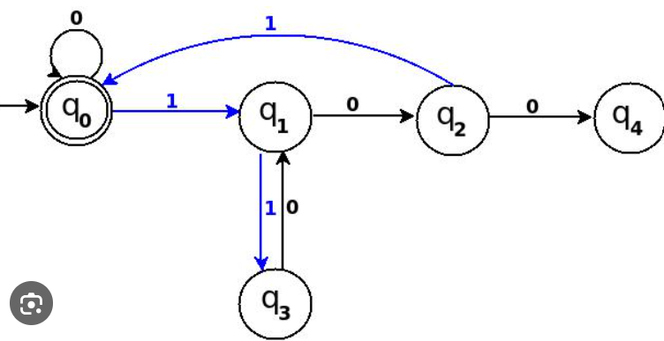  The DFA is already minimised. Steps has to be shown | 12 | 3 | 1 | 3 | 3.3.2

*Performance Indicators are available separately for Computer Science and Engineering in AICTE examination reforms policy.

Course Outcome (CO) and Bloom’s level (BL) Coverage in Questions

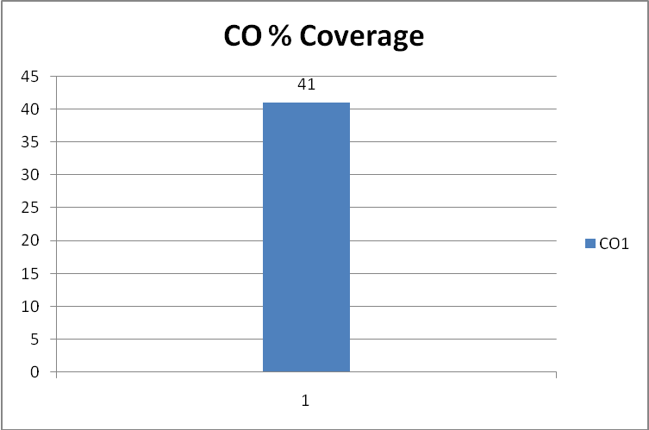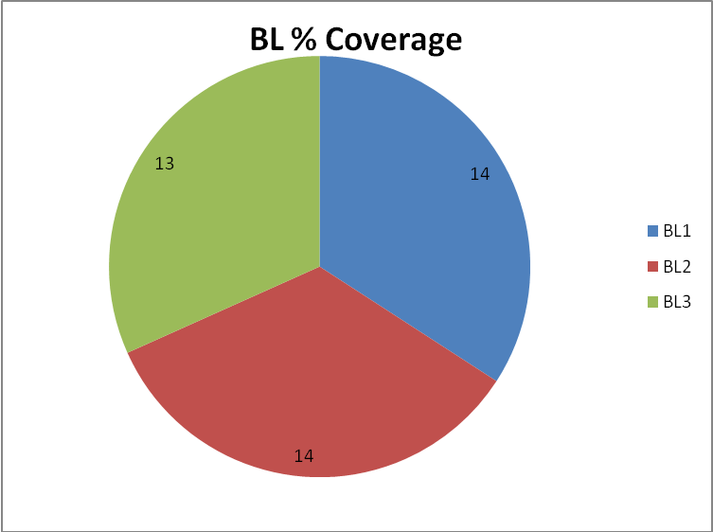

Approved by the Audit Professor/Course Coordinator

